**Assignment 1**

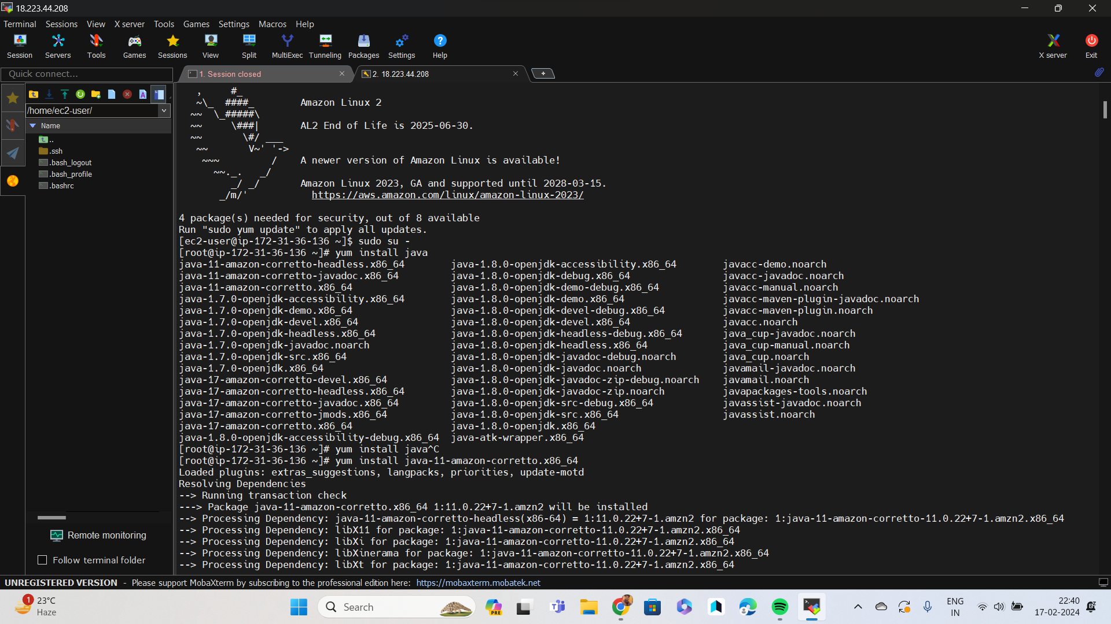Installed java 11

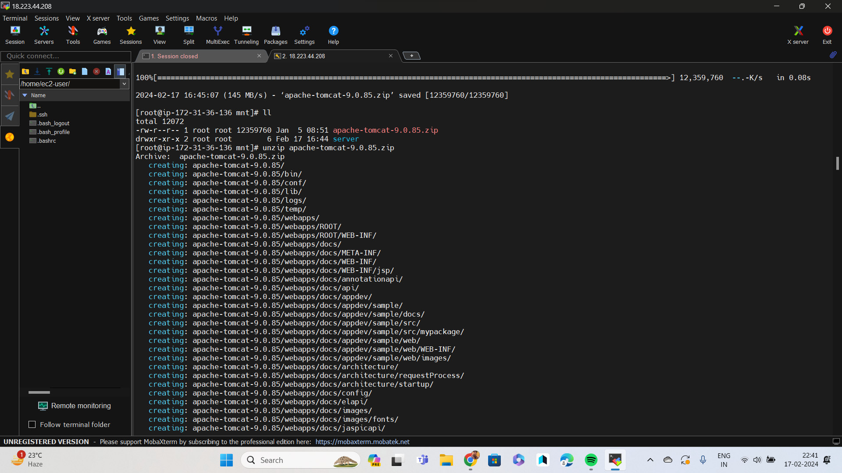Downloaded and unziped tom cat server

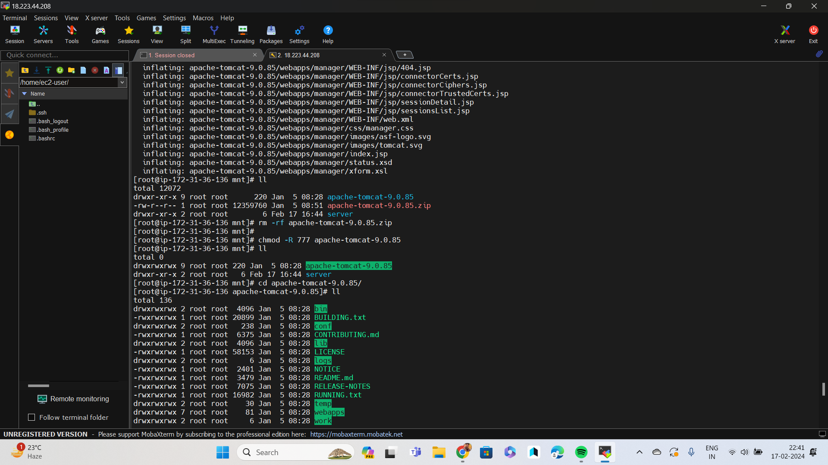Given full permission to the tomcat server

Download jenkis war file in webaaps

Run the sh script in bin

Open the jenkins g interface via publicip:8080/jenkins

Created a jinks master

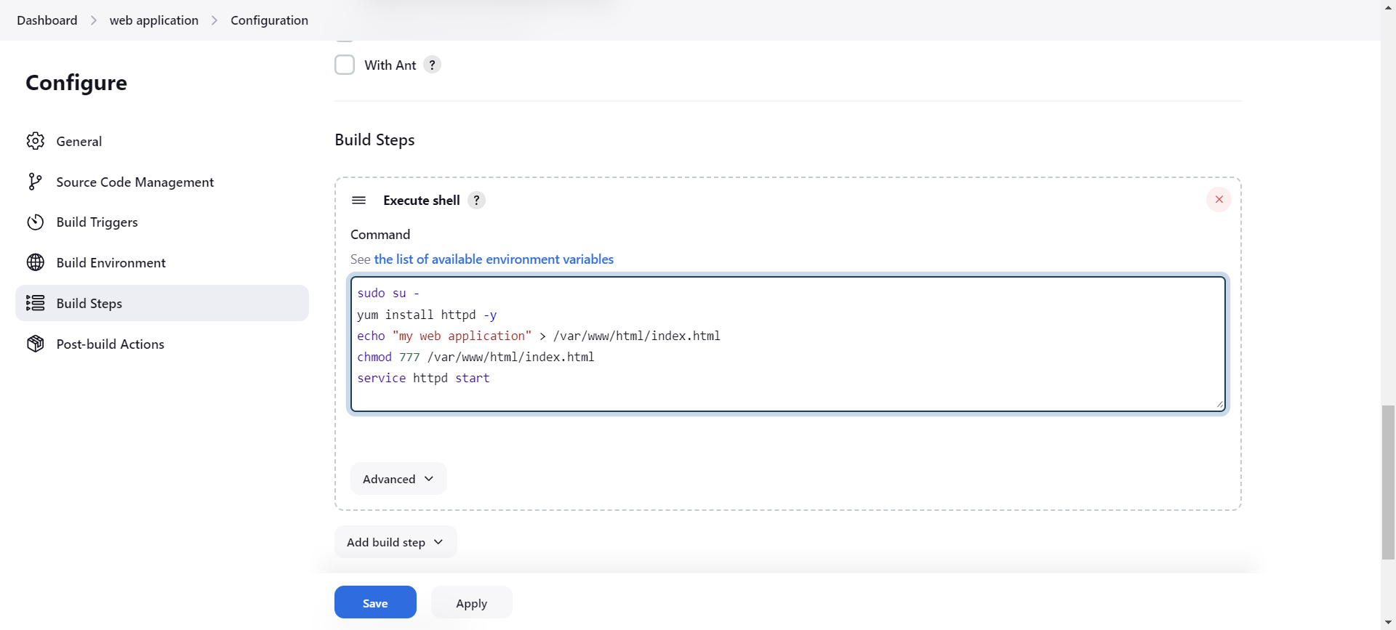 created a job and script for web application

Builded the job

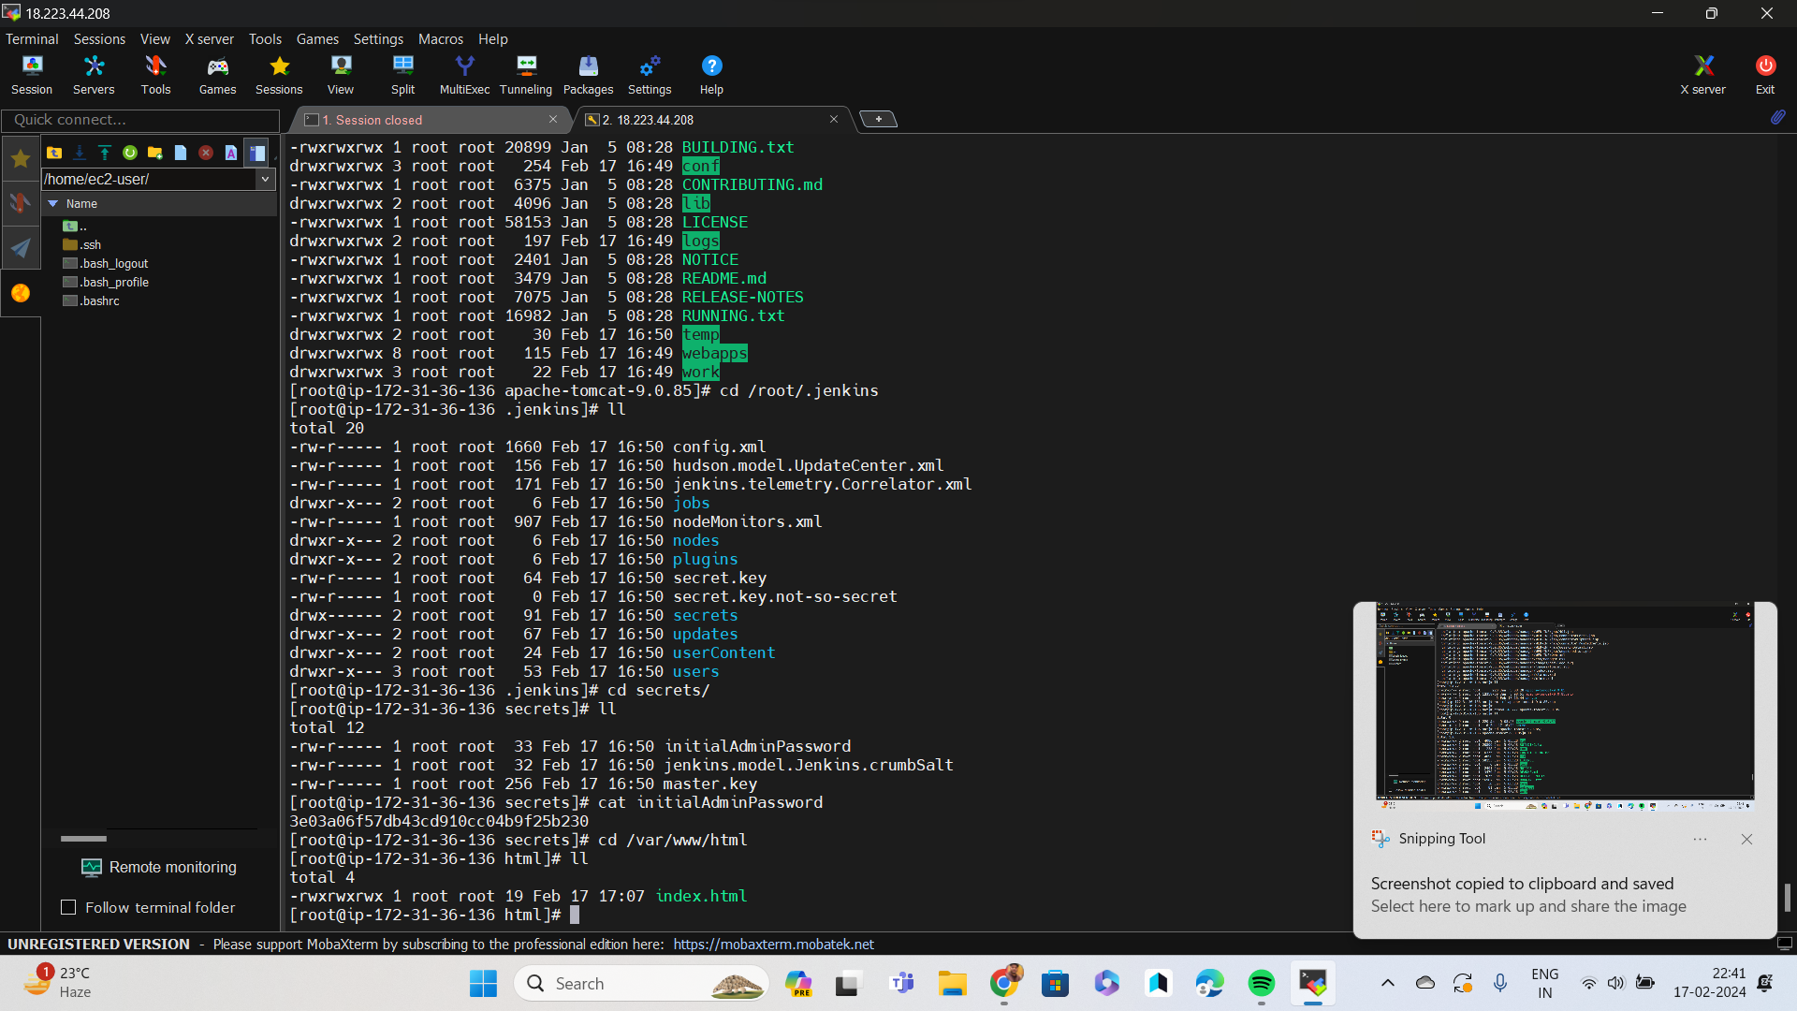Checked wether the file is created or not

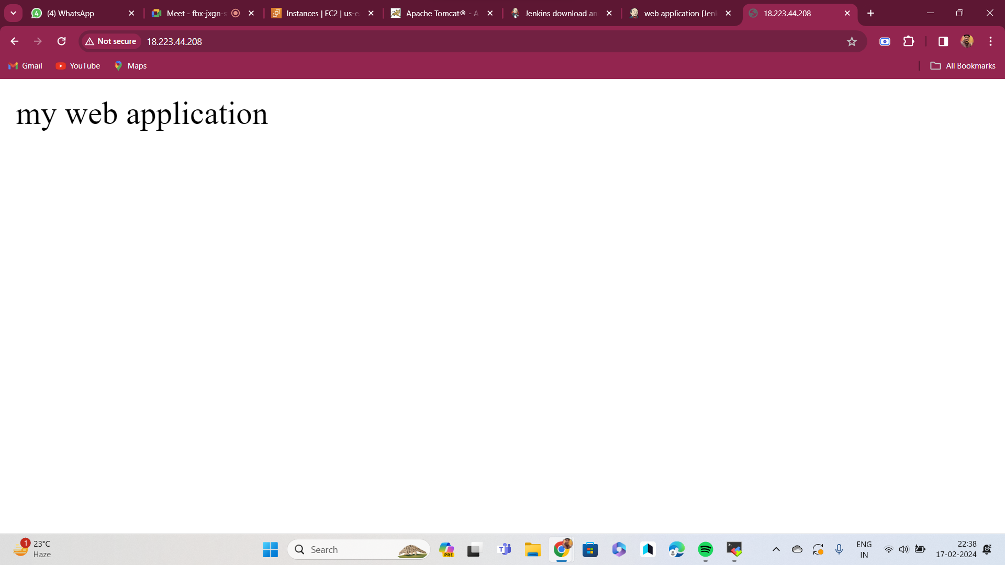Application is running